**Towards a new stable state: Equitably assessing trainee writing productivity post-COVID-19**

FREYA E. ROWLAND*1,2

KYRA A. PRATS*1

YARA A. ALSHWAIRIKH

MARY K. BURAK

ANA CLARA FANTON

MARLYSE C. DUGUID

*co-first authors

1School of the Environment, Yale University, New Haven, CT USA

2Corresponding author: frowland@usgs.gov

***Contributions***

F.E.R., K.A.P., Y.A.A., M.K.B., A.C.F., and M.C.D. designed the research and distributed the survey. F.E.R. conducted the analyses and K.A.P contributed. F.E.R., K.A.P., Y.A.A., M.K.B., A.C.F., and M.C.D. interpreted results. F.E.R., K.A.P., Y.A.A., M.K.B., and A.C.F. wrote the original manuscript. All authors contributed to the editing and the final draft. Middle authors are in alphabetical order.

**ABSTRACT**

The current academic ‘ecosystem’ prioritizes publications and has remained in this stable state despite increasing calls for change. Although writing is a strong determinant of academic success, certain groups may experience publishing barriers that may be amplified by disruptive events like the COVID-19 pandemic. Here we surveyed 342 graduate students and postdoctoral scholars to assess (1) how identity predicted publishing outputs and (2) how the pandemic influenced feelings of writing productivity based on identity. We show that there were differential publication totals across identities. Respondents reported feeling less productive and motivated during the pandemic, despite having more time to write. BIPOC graduate students reported being the most negatively impacted. Since the pandemic disproportionately affected historically excluded groups, we urge the academic ‘ecosystem’ to transition away from an overemphasis on publication outputs and reach a new, more equitable stable state that evaluates accomplishments more holistically.

**Keywords:** graduate student, identity, pandemic, postdoctoral scholar, publications

**Learning the nuances of academic writing is nonlinear** and writing challenges can emerge at any point in one's career. Trainees (i.e., graduate students and postdoctoral scholars, hereafter postdocs) are learning how to communicate their research through writing manuscripts for publication. For trainees seeking tenure-track positions, successful applicants are often those who have published the most (Rybarczyk et al. 2016, Fox 2020). The number of publications by recently hired trainees has doubled over time (Brischoux and Angelier 2015) and high publication totals are critical for securing academic employment (Sanchis‐Gomar 2014). This creates a feedback loop where increased competition among job applicants has led to increased publication totals that trainees seeking academic research positions feel pressured to produce .

Despite broad awareness of the importance of academic publishing, there is evidence that writing output is not equal across identity groups. The range of affiliations that one holds, or identity (**Box 1**) can be associated with differential access to writing support and output. Students from underrepresented backgrounds face many barriers to accessing higher education (Farmer-Hinton 2008), such as difficulty obtaining support and guidance for applying to college — a process that involves significant writing. This differential access to writing support extends throughout undergraduate years, and likely persists in graduate school as well. Prior to the COVID-19 pandemic (hereafter the pandemic), research showed that historically excluded (e.g., Black, Indigenous, People of Color [BIPOC] (**Box 1**), women) graduate students in STEM fields were less likely to publish than white male graduate students (Mendoza-Denton et al. 2017). Many graduate students—especially historically excluded groups (HEGs, **Box 1**) and those whose first language is not English—experience anxiety while writing (Huerta et al. 2017, Gardner et al. 2018). Researchers with disabilities have reported having fewer resources to assist with academic publishing compared to researchers who did not identify as having a disability (Suart et al. 2021). There is a gap in the literature regarding how trainees from other HEGs—such as first-gen and gender non-binary trainees—may be impacted by the pressure to publish. The studies that do exist record experiential challenges but do not quantitatively explore how identity may influence trainee publication outputs. The importance of increasing diversity within academia is recognized (Montgomery 2021), yet faculty hiring is hierarchical and unequal. For example, women are often hired by less prestigious universities than male peers from the same doctoral institutions (Clauset et al. 2015). Women of color, whose experiences intersect at race and gender (Ko et al. 2013), are underrepresented in higher levels of academia (National Science Foundation and National Center for Science and Engineering Statistics 2019). Furthermore, some trainees from HEGs may spend significant time on service towards improving Justice, Equity, Diversity, and Inclusion (JEDI) initiatives within academia. Post-graduation, many women of color reported a strong desire to engage in activism, increase diversity, and improve conditions for other BIPOC women in STEM (Ko et al. 2013). BIPOC women faculty have reported that engaging in activism—rather than focusing solely on research—led to forfeiting their full professor rank but felt advocating for HEGs was more important (Ko et al. 2013).

Increasing diversity in academia necessitates fair assessment of scholars. Within the current academic system, the main metric of success is tangible outputs such as publications and grants (Ravenscroft et al. 2017). There have been multiple internal calls change, particularly for being held accountable for how we achieve outputs (i.e., being a good leader, teacher, and mentor, without harming other community members; Montgomery 2021) and prioritizing equity for our community members (Maas et al. 2020, Schell et al. 2020, Fulweiler et al. 2021, Montgomery 2021).Academic communities must also understand how life experiences affect trainee publishing output, including how identity may intersect with major life upheavals.

We use the stable state ecology framework (Beisner et al. 2003) as an analogy for academia and the impact of the pandemic. Similar to an ecosystem, academia is comprised of a community of individuals that work in various roles and function as a unit. Therefore, we can think of academia as an ecosystem that persists under a stable state, but that can be vulnerable to small-scale perturbations and larger-scale disturbances. A disturbance in the ecological framework is defined as a relatively discrete event “that disrupts the structure of an ecosystem, community, or population, and changes resource availability or the physical environment” (White and Pickett 1985) and, thus, can alter the state of the ecosystem We argue the pandemic can be thought of as a major disturbance of the academic ecosystem. It introduced new challenges to academic work that impacted certain groups more than others (Myers et al. 2020). Furthermore, the pandemic has amplified the unjust differences that currently exist within academia that were perhaps more difficult to discern prior to the pandemic.

We argue that the pandemic disturbance has been so disruptive that it has the potential to shift the entire academic ecosystem to a new, more equitable stable state where new metrics may be introduced to add to the traditional metrics of success. The academic ecosystem is at a tipping point (Johnson et al. 2020) where we can either settle back into the existing state (**Fig. 1B**) or use the disturbance and insights of the pandemic to move toward a more equitable stable state of valuing scientific productivity (**Fig. 1D**).

Although recent publications highlight how the pandemic affected faculty (Cardel et al. 2020, Myers et al. 2020), there is little understanding of how it impacted trainee writing productivity. Here, we (1) conducted a survey to contextualize how the pandemic and identity may interact to disproportionately affect historically excluded trainees, (2) show ways in which the academic ecosystem is at a tipping point from the pandemic disturbance, and (3) propose what the new, more equitable state looks like for the academic ecosystem.

**METHODS**

***Survey Design and Distribution***

During March – April 2021, we used an anonymous Qualtrics survey to ask academic trainees (i.e., graduate students and postdoctoral scholars, hereafter postdocs) currently working at American and Canadian Universities within environmental biology fields to self-identify their demographic information, publication records leading up to the COVID-19 pandemic, career goals, and the effects of the COVID-19 pandemic on their feelings towards writing habits and productivity (full survey available in **Supplementary Information**). We chose to limit the sample frame to minimize differences due to STEM sub-field publishing practices [(Mendoza-Denton et al. 2017)](https://www.zotero.org/google-docs/?9UUYkV).

We were approved for IRB exemption under 45CFR46.104 (2)(ii) and did not track any personal identifying information or geographic location (e.g., IP address) to allow for honest and open answers. To encourage responses, we offered respondents the option of entering a gift card drawing not linked to survey responses. Survey completion was voluntary, and we advertised it via social media (Twitter, Reddit, Facebook, Instagram), targeted emails to colleagues, and posted the survey twice on the ECOLOG-L listserv hosted by the Ecological Society of America. To increase the geographic diversity of the sample frame, we emailed 98 different department chairs or graduate coordinators from at least one major public R1 university in each U.S. state and Puerto Rico, U.S. Ivy League institutions, and five R1 Canadian Universities and asked them to distribute our survey among trainees. While we targeted R1 universities for distribution of our survey through emails, it is probable that trainees from non-R1 institutions filled out our survey after finding it on social media; however, we cannot determine the percentage of trainees from R1 or non-R1 universities. We did not require respondents to answer all questions; therefore, some respondents skipped questions or left fields blank. We eliminated these blank or skipped responses and categorized them as “NA”, but as a result, the sample size differs between questions. We denote sample size either in text or in figure captions to account for this.

***Data Analysis***

We fit Bayesian multiple linear regressions in R version 4.0.2 (R Core Team 2020) using ‘rstanarm’ (Goodrich et al. 2020)to estimate how training years and identity affect total publications using a Gaussian distribution and estimated whether identity impacted the probability of a respondent indicating the pandemic affected their writing using a binomial distribution and logit link function. We then used ‘bayesplot’ (Gabry and Mahr 2020) for visualization. For each model, we used weakly informative normal prior distributions with a mean of zero and standard deviation of 2.5 for predictions as suggested by experts (Gelman et al. 2008) and then allowed rstanarm to automatically scale and center predictors and adjust scales of the priors during each run, which are also the default settings in ‘rstanarm’ (Goodrich et al. 2020). We ran four chains for 10,000 iterations and discarded the first half as warm-up to obtain 20,000 simulations for analysis. We confirmed convergence using the Gelman-Rubin statistic(Rhat < 1.01) and by examining trace plots. None of the models had influential outliers as assessed by leave-one-out cross-validation (“loo”) in the ‘rstan’ package (Stan Development Team 2020). We report model coefficients as the median (βhat in text, point estimates in Figures 2 and 4) and credible intervals (e.g*.*, a 95% credible interval indicates there is a 95% probability that the true parameter lies within that range). Bayesian posterior distributions are generally more intuitive because they are probabilistic (McElreath 2020), so we used the thousands of iterations per model (i.e., posterior) to look at the probability of the coefficient being positive or negative, which we report in text as the % probability a coefficient is < or > 0.

We used years as a graduate student and as a postdoctoral scholar as continuous variables. Identity factors were coded as whether the respondent was part of the group (yes = 1) or not (no = 0). Identity factors included whether someone was the first in their family to obtain a college degree (first generation, hereafter first-gen); gender identity; whether a trainee identified as BIPOC; whether the trainee had a chronic health condition or disability; and whether the trainee’s first language was English or not. Unfortunately, we had too small of a sample size of individuals identifying as non-binary/other (e.g., non-binary, third gender, etc.) to get accurate model results (n = 8/311 respondents), so we eliminated all but those who identify as male or female from the analysis on publication totals. Recognizing that these individual survey respondents have shared insights from their experiences, we express deep gratitude for their voluntary contributions. Although these data were too minimal to statistically test how being gender non-binary affected publication outcomes, we encourage readers to view a summary of these responses (**Supplementary Table S6)**.

**RESULTS**

***Sample frame***

We had 355 survey respondents—292 of whom finished the entire survey—from 149 subfields of environmental biology (**Supplementary Fig. S1**). The most common subfield descriptions included “ecology” (n = 158), “biology” (n = 44), “evolutionary” (n = 34), and “plant” (n = 29). Our sample frame included graduate students from early to advanced stages (0-15 years, avg = 4.7 years, SD = 2.7, n = 231/311), and postdocs who had a similar range of experiences from early to advanced stages (0-9 yrs, avg = 1.9, SD = 1.9, n = 80/311).

Respondents represented a diversity of identities (**Supplementary Table S1**). The majority of graduate students (73%, n = 140/193) and postdoc respondents (61%, n = 46/76) self-identified as female (**Box 1**), while 24% and 37% (n = 47/193 and n = 28/76; graduate students and postdocs, respectively) self-identified as male, and a small number self-identified as non-binary, third gender, or other (3%, n = 6/193; and 3%, n = 2/76). Most respondents (92%) were previously or are currently at a university in the U.S. or Canada, therefore our results mainly reflect trainee experiences in this region of North America.

Overall, 20% (n = 53/267) of respondents self-identified as BIPOC, comprising 24% of graduate students (n = 46/193) and 9% of postdocs (n = 7/74). First-gen college graduates made up 24% of both graduate student (n = 46/194) and postdocs (n = 19/78) respondents. Additionally, 18% of respondents reported having a disability or chronic health condition (**Box 1**), with 20% of graduate students (n = 39/193) and 13% of postdocs (n = 10/77). Finally, 18% (n = 36/199) and 23% (n = 18/78) of graduate students and postdocs, respectively, reported that English was their second language (ESL, **Box 1**).

***Publishing output pre-COVID-19 pandemic is predicted by training and identity***

A substantial number (40%) of trainees had published prior to starting graduate school (n = 123/310); comprising the time period before and during the COVID-19 pandemic. Postdocs had more first- (avg = 5.1 versus 1.7) and co-authored publications (avg = 5.6 versus 2.5) on average than graduate students and the variation in both metrics was higher among postdocs (**Supplementary** **Fig. S2**). The strongest effect on publication total prior to the pandemic was the number of years spent as a trainee (**Fig. 2, Supplementary Tables S2 and S3**). Each additional year in training resulted in an additional half of a publication for graduate students (βhat = 0.52, 100% of posterior samples [hereafter probability] > 0; **Fig. 2A**) and slightly less for postdocs (βhat = 0.33, 82% probability > 0; **Fig. 2B**). Years spent as a postdoc had a strong effect. Each additional postdoc year resulted in two more publications (βhat = 2.10, 100% probability > 0; **Fig. 2B**).

Our models found contrasting effects of identity on publication totals between graduate students and postdocs (**Fig. 2**, **Supplementary** **Tables S2 and S3**). First-gen identity was associated with a slight increase in publication totals for graduate students (βhat = 0.44, 79% probability > 0), but had little effect on postdocs (βhat = -0.75, 67% probability < 0). Female identity was a neutral factor for graduate students (βhat = -0.03, 52% probability < 0), but reduced postdoc publication total by 1.4 (βhat = -1.39, 81% probability < 0). BIPOC graduate students had slightly fewer publications than non-BIPOC peers (βhat = -0.28, 69% probability < 0), but BIPOC postdocs published more papers than non-BIPOC peers (βhat = 1.40, 70% probability > 0). Graduate students with chronic conditions had approximately one fewer paper (βhat = -0.80, 91% probability < 0), but postdocs with chronic conditions had more papers (βhat = 1.58, 77% probability > 0). Graduate students with ESL had slightly fewer papers than non-ESL peers (βhat = -0.35, 76% probability < 0). Having ESL had little effect on publishing productivity of postdocs (βhat = -0.76, 65% probability < 0), although ESL trainees were the only identity to provide qualitative descriptions of their difficult experiences in an open response (**Table 1**).

***Differential impact of the COVID-19 pandemic on perceived writing time, productivity and motivation***

The majority of respondents (70%, n = 197/279) reported that the pandemic impacted their writing habits (**Fig. 3A**). When respondents answered “yes” to the overarching question “Has the COVID-19 pandemic impacted your writing habits?” they were directed to a series of nested questions about perceived writing time, productivity, and motivation during the pandemic. Despite most trainees (52%, n = 101/195) reporting having had more or much more time for writing during the pandemic (**Fig. 3B**), a combined 75% of respondents (n = 147/196) reported that they felt less or much less productive during the pandemic (**Fig. 3C**). Similarly, 76% (n = 148/196) of respondents reported feeling less or much less motivated to write during the pandemic (**Fig. 3D**).

Participants’reported experience with their writing habits during the pandemic was unequal across identity. Specifically, most female respondents (74%, n = 131/176) reported that the pandemic impacted their writing habits, compared to 61% of those who identify as male (n = 46/75) and 63% (n = 5/8) of non-binary trainees. Strikingly, 85% of BIPOC trainees reported that their writing habits were impacted by the pandemic compared to 67% (n = 142/212) of white peers. Our models that accounted for identity and years in graduate school supported these results and suggested with a high degree of certainty (**Supplementary Table S4**) that first-gen, female, or BIPOC graduate students were more likely to have the pandemic impact their writing habits (**Fig 4A**). First-gen graduate students had a 72% probability and female graduate students had a 61% probability of answering that their writing habits were affected. BIPOC graduate students had the highest (89%) probability of reporting the pandemic affected their writing. Number of years spent in graduate school was unrelated to the impact of the pandemic on writing (1 year = 51% versus 5 years in graduate school = 54% probability). Interestingly, graduate students with ESL were strongly unlikely to report that the pandemic affected writing habits (100% posterior < 0), with only a 17% probability (**Fig. 4A**, **Supplementary Table S4**).

Among postdocs, those who have spent longer in postdoctoral training and who identify as female were the most likely to report that the pandemic affected their writing, whereas postdocs with chronic conditions and ESL were statistically unlikely to report an effect on writing habits (**Fig. 4B**, **Supplementary Table S5**). Each additional year of postdoc training increased the probability of the pandemic affecting writing habits by 6% (96% posteriors > 0; e.g., 1 year postdoc prob = 57% versus 4th year prob = 75%). Female postdocs had a 66% probability of being affected by the pandemic (89% posteriors > 0). Postdocs identifying as first-gen and BIPOC reported little to no effect of the pandemic on writing (**Fig. 4B, Supplementary Table S5**). Postdocs with ESL had only a 20% probability (98% posteriors < 0) of saying the pandemic affected their writing, and postdocs with chronic conditions a 22% probability (95% posteriors < 0).

**DISCUSSION**

We show the pandemic disturbance substantially and unequally affected writing habits of trainees and argue for a shift to a new stable state with how academia values success and productivity. The impacts of the pandemic were disproportionately experienced by HEGs — 85% of BIPOC and 74% of female trainees reported that their writing habits were impacted. While our sample frame only included environmental biology fields, the pressure to publish and the inequalities of academia are not exclusive to environmental biology fields, thus our survey results can be relevant for the entire academic ecosystem. Our results suggest that the pandemic may worsen diversity in academia because its current structures and insufficient support may push historically excluded trainees to leave the academic pipeline. To reach a new, more resilient [(Walker et al. 2004)](https://www.zotero.org/google-docs/?a4v53h) and equitable stable state in the academic ecosystem after the pandemic disturbance (**Fig. 1D**), we must acknowledge that basing hiring mainly on trainee publication and grant output disadvantages HEGs and ignores other strengths (e.g., teaching, leadership, mentoring, being a good community member) that academic candidates might offer.

***Diversity, equity, and inclusion in scientific writing***

Our results strongly demonstratethat female trainees and those with chronic conditions had lower publication output pre-pandemic compared to their peers (**Fig. 2**). While we do not necessarily know how these results might change over time, given the emphasis on publication output in the current state of the academic ecosystem, it is likely lower outputs at some point in one’s career will have a lingering effect regardless of future progress. Interestingly, graduate students and postdocs often had contrasting results with respect to how identity affected publication output. Graduate students had similar publication records across genders, but female postdocs had 1.4 fewer publications than their male counterparts. Postdocs are more likely to have children than graduate students given that they tend to be older (Davis 2005, Serrano 2008, Shah et al. 2021), and this could disproportionately affect the child-carrying and primary caregiving partner, although further research is needed to explore this. However, even for women without children, gender schemas (Valian 2004) and deliberate and systematic obstacles (i.e. the hostile obstacle course [Berhe et al. 2022]) make it harder for women to succeed in academia. This causes women to leave during the transition from graduate student to postdoc (National Science Foundation and National Center for Science and Engineering Statistics 2019) and from postdoc to faculty (Martinez et al. 2007).

First-gen graduate students had more publications than their non-first-gen peers but there was no difference at the postdoctoral level (**Fig. 2**). Others have found first-gen biology doctoral students have similar experiences and outcomes as non-first-gen peers, matching our results (Roksa et al. 2018), but our weak trend at the postdoctoral level shows that we need more data to understand how first-gen postdocs might respond to pressures postdoctoral positions and uncertainty in the job market. BIPOC trainees and trainees with chronic conditions tended to have fewer publications as graduate students but more as postdocs (**Fig. 2**). People from HEGs finishing STEM PhDs are half as likely to have submitted a paper in the previous year compared to people from non-HEGs (Mendoza-Denton et al. 2017) and in-depth surveys suggest high writing anxiety among BIPOC biomedical graduate students (Gardner et al. 2018). Graduate students experience major institutional sources of stress during their degrees including role strain (e.g., being a teacher but also a student), mentor relationships, isolation, and funding concerns (Grady et al. 2014); how these graduate school stressors may build upon the strain of being part of a HEG needs to be explored and addressed.

Trainees with ESL had slightly fewer publications than trainees with English as a first language. Although these trends were weak, many respondents explicitly mentioned the struggles of English as the default language of science in the open response section (**Table 1**). Research shows that trainees with ESL face enormous obstacles to scientific publishing (Powell 2012), but writing intervention programs have helped this group gain confidence and skills in scientific writing (Gardner et al. 2018). Universities should invest in extra resources for trainees with ESL, including discipline-specific writing courses (Allison et al. 1998, Lax 2002).

Our results, alongside previous work [(Mendoza-Denton et al. 2017)](https://www.zotero.org/google-docs/?4aEH8c), demonstrate that certain groups of trainees had lower publication outputs than their peers leading up to the pandemic. We need to shift the academic ecosystem, currently structured to differentially impact identity groups under baseline conditions (Schell et al. 2020, Montgomery 2021). The pandemic has highlighted and in some cases accentuated the unjust differences that exist for community members. Although significant and global disturbances like the pandemic are uncommon, the productivity disruptions mirror more singular events that individuals experience such as grief, illness, or unpredictable childcare, so adjusting to a more equitable state will have long-reaching positive effects on future trainees seeking tenure-track positions.

***COVID-19 pandemic and identity***

Graduate students and postdocs have navigated the impacts of the pandemic at a critical time in their careers when publishing matters most for their future career success. While recent studies have examined the effect of the pandemic on early-career faculty (Cardel et al. 2020, Myers et al. 2020, Herman et al. 2021), our study is the first to our knowledge that quantitatively examines the impact of the pandemic on trainees (but see Suart et al. (2021) for a qualitative overview). The differential writing outputs across trainees may be exacerbated by the ongoing pandemic. The majority of trainees reported that the pandemic has affected their writing habits, with most also feeling less productive and motivated to write (**Fig. 3**). Thus, while these trainees felt that they had more time for writing during the pandemic, it was not actually conducive to writing productivity or motivation. This finding is not surprising; other studies have explored the connection between negative mental health, feelings of apathy, and lower productivity and motivation (Suart et al. 2021). Mental health was already a concern for trainees (Evans et al. 2018), and the pandemic will likely worsen anxiety and depression (Woolston 2020a, Abbott 2021). Furthermore, 70% of respondents preferred working in non-home environments that were unavailable during lockdown. Many trainees were likely adjusting to working from home while living in smaller shared spaces with roommates or family. Trainees who are parents had the additional challenge of caring for their children; women have been disproportionately affected by increased childcare or other family caretaking responsibilities stemming from the pandemic (Cardel et al. 2020, Myers et al. 2020, Pinho-Gomes et al. 2020).

However, the pandemic has not affected all trainees equally. While there was no effect of years spent in graduate school, each additional year of postdoctoral work strongly increased the reported effect of pandemic on writing habits (**Fig. 4**). Most postdoctoral positions in environmental biology fields are for 2-3 years at most, so losing 1.5 years of access to networking, lab work, and field sites was devastating, especially when paired with grim job prospects (Kelsky 2020, Levine and Rathmell 2020) and the importance of publishing during postdoctoral work (Fox 2020). Despite calls for more support and contract extensions (Ahmed et al. 2020, Park 2020), many universities did not accommodate postdocs. Postdocs are deeply concerned that the pandemic has worsened their overall career prospects (Park 2020, Woolston 2020b).

We also found evidence that female trainees were disproportionately affected. The experience of non-binary and other gender trainees was similar (**Supplementary Table S5**), but more data are needed to more fully characterize their experience throughout the pandemic. Other studies have also reported gender inequalities in research productivity during the pandemic, including women having less time for research (Myers et al. 2020) and being underrepresented in COVID-19-related research and authorship (Andersen et al. 2020, Pinho-Gomes et al. 2020, Bell and Fong 2021). Actions such as creating niche funding opportunities to support women and gender minorities and developing flexible working schedules for those with childcare responsibilities have been proposed as strategies for supporting these early-career scientists (Cardel et al. 2020). Additionally, creating institutional resources for writing (e.g., courses, workshops, support groups) could help mitigate the effects of unexpected disturbances.

Disparities in the pandemic’s impact on writing were most pronounced for BIPOC respondents. A striking 85% of BIPOC trainees reported that the pandemic affected their writing habits, and overwhelmingly felt unproductive and unmotivated to write. The timing of the pandemic also coincided with the collective trauma felt by Black Americans in response to police brutality and the murders of Breonna Taylor and George Floyd, among others. Furthermore, violence directed at Asian Americans has been on the rise in the U.S. during the pandemic (Nuyen 2021). We recognize that this violence transcends workspaces and can manifest in field work settings as well (Demery and Pipkin 2021, Montgomery 2021). Although our data do not differentiate between the public health and social justice crises, the compounding issues of the pandemic, racism, and the rise of racially-charged violence likely contributed to the decreased writing motivation felt by BIPOC trainees. It is critical for BIPOC trainees to take care of their mental health (Tseng et al. 2020), and for academic communities to support and retain BIPOC trainees by dismantling institutional white supremacy and creating inclusive environments where BIPOC scholarly excellence is celebrated (Maas et al. 2020, Schell et al. 2020, Cronin et al. 2021, Montgomery 2021). Future research should aim to disentangle the role of longstanding inequities in academia and the effects of recent events (e.g*.*, the pandemic and the social justice movement of 2020) on work output.

First-gen graduate students were also more likely to report a disruption to writing during the pandemic, which may be due to the mental toll of having more family and friends with low socioeconomic status who struggled more throughout the pandemic (Ojha 2020). Surprisingly, trainees with ESL and those with chronic conditions were statistically less likely to report the pandemic affected their writing habits (**Fig. 4**). More research is needed to understand why these trainees reported less interruption to writing habits.

The intersection of identities, such as race and gender, is important (Charleston et al. 2014) and undoubtedly would add new insight and a fine-tuned understanding of how different identities were affected by the pandemic. Though we did not analyze the intersections of race, gender, first-gen, ESL, and chronic conditions/disability in the interest of retaining statistical power to answer larger questions on inequities, we encourage future studies to quantitatively assess intersectionality of different identities and include more nuance in their assessments.

***A new stable state***

We show that the pandemic disturbance disproportionately affected historically excluded environmental biology trainees. Female, BIPOC, and first-gen trainees were much more likely to indicate that the pandemic impacted their writing habits. These writing interruptions may linger on the CVs of those who were trainees during the pandemic, manifesting as disparities in publication counts compared to more productive colleagues and competitors. To recover post-pandemic from the disturbance to our academic ecosystem, we must provide enhanced writing support and reconsider how to evaluate productivity and establish values in future hiring. The current evaluation metrics are not equitable because they do not (1) account for the different input into individual publications, (2) give equal weight to the non-publishing aspects of academia (e.g., teaching, mentoring, JEDI), or (3) account for the means by which academics achieve their outputs (Montgomery 2021). Research projects that are theory-, lab-, or field-based require different inputs from inception to publication. Search committees should consider these project inputs when evaluating candidates beyond total publication counts and journal impact factors. Further, while peer-reviewed publications maintain the quality and knowledge-base of science, the non-publishing aspects of academia—essential for improving the academic ecosystem—should be given more weight in the evaluation process. For example, on its own, a candidate’s publication output does little to impact the issue of undergraduates from HEGs leaving STEM degrees (Hunter 2019) or graduate students leaving academia. However, a candidate with training and experience in inclusive teaching practices and active participation in JEDI initiatives is likely going to improve their prospective institution by being both a good instructor and mentor. Finally, while a candidate can have an exceptional track record of publications and grants, they may have achieved those outputs while harming community members around them (Montgomery 2021); thus, a more holistic approach is necessary for evaluating academic success. Ultimately, we need to improve the system that perpetuates inequity prior to future major disturbances. While the academic ecosystem has made some progress in including alternative metrics beyond publications, it still has a long way to go. The differential impacts of the pandemic on HEGs, along with the call to create and retain a diverse and equitable faculty is an opportunity to universities to reevaluate and adapt their current metrics.

Non-white, non-male, and first-gen faculty are more likely to participate in JEDI activities (Jimenez et al. 2019). If trainees engaging in and prioritizing institutional service and JEDI initiative have similar identities, these individuals may have less time to dedicate to writing. That participation in these important initiatives is not equal amongst identities further highlights the lack of equity in the current evaluation process.

To conclude, committees should evaluate faculty candidates holistically, not only placing outsized attention on scientific contributions (e.g., publications stemming from research grants), but also seek well-rounded individuals who will serve as good advisors and community members. Although there have been perturbations to the academic system calling for change (Montgomery 2021, Nocco et al. 2021) or support for HEGs (Maas et al. 2020, Tseng et al. 2020; **Fig. 1A**) we urge the ivory tower to use the pandemic disturbance to permanently move beyond its overemphasis on publication totals as an almost singular metric of scientific success (Brischoux and Angelier 2015; **Fig. 1B**). We propose moving to a new stable state [(Beisner et al. 2003)](https://www.zotero.org/google-docs/?pSr8UD) of comprehensively assessing trainee contributions to the academic ecosystem by includingservice, teaching, mentorship, and JEDI initiatives (**Fig. 1D**). In transitioning to a new stable state, the academic ecosystem could become more inclusive, vibrant (Hansen et al. 2018), and resilient to future disturbances.

**Acknowledgements**

Thank you to the trainees that answered our call for survey responses about writing. We would not have any data without you. We also thank the Yale StatLab at the Marx Science and Social Science Library for feedback on survey design. J. Monk, N. Harris, S. Gámez, L. Baik, K. McConnell, C. Wilkinson, and M. McCary provided helpful feedback on earlier versions of the manuscript. Finally, we would like to thank the editor and two anonymous reviewers for their thoughtful feedback on our manuscript.

**FIGURES AND TABLES**

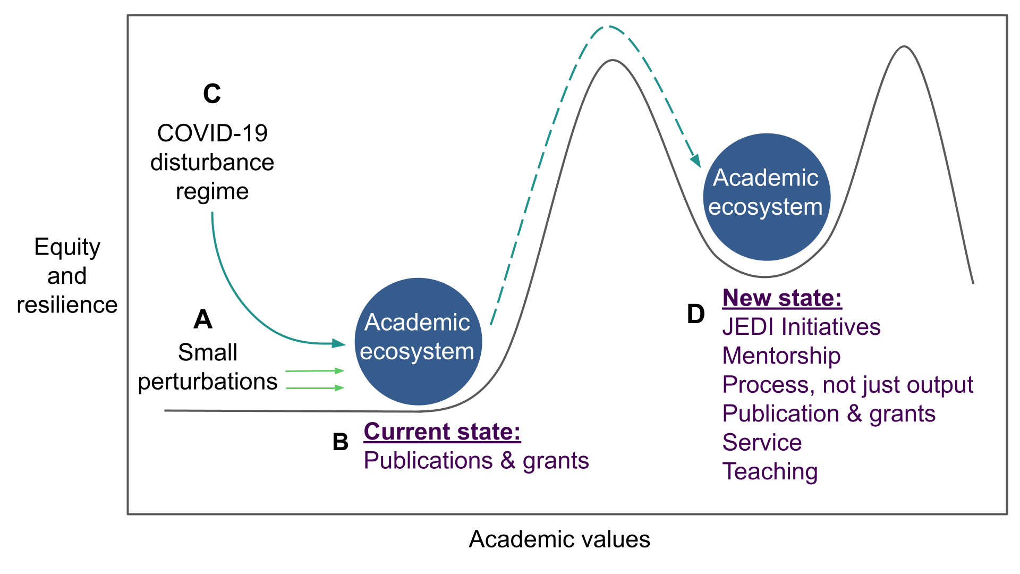

**Fig 1**. Using an ecological framework, the COVID-19 pandemic is a major disturbance that can push the academic ecosystem to a new, more equitable state. A) The academic ecosystem has experienced small perturbations calling for change to the system, such as the need to diversify. B) Within the current state of the academic ecosystem, the main metric of success is publications and grants. C) The disturbance of the COVID-19 pandemic can shift the academic ecosystem to a new, more equitable stable state. D) This new stable state is characterized by equal valuation of the publishing and non-publishing aspects of academia, and individuals are valued holistically. Value is placed on the process rather than mainly on the number of outputs (i.e., publications, grants, and citations; Montgomery 2021) While the characteristics of the new stable state certainly are present in the current academic ecosystem, in the new ecosystem state they should given more weight.

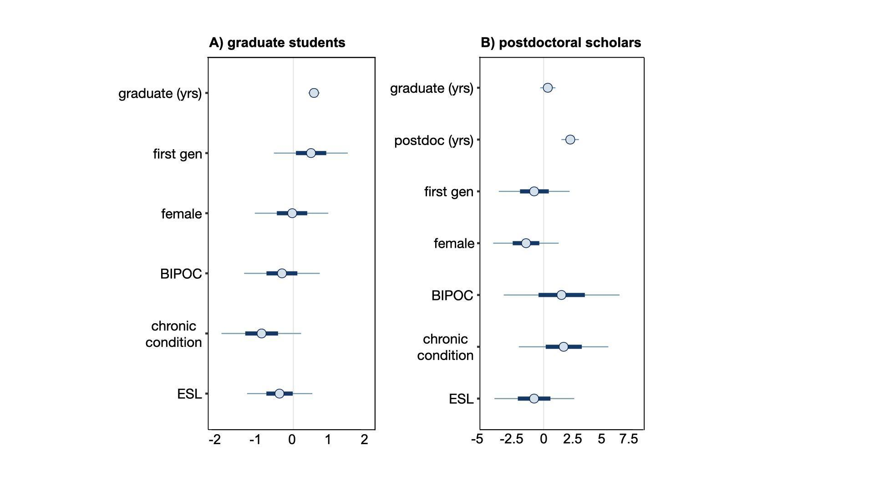

**Fig. 2. The effect of years in training and identity on total publications for A) graduate students (n = 229) and B) postdoctoral scholars (n = 79) leading up to the COVID-19 pandemic.** Multiple regression models suggest that identity of graduate students and postdoctoral scholars predicts publication totals. Each point is the median parameter estimate, thick lines are 50% credible intervals (CRIs), and thin lines are 95% CRIs. Graduate and postdoc yrs indicate the number of years in training (as a continuous variable). First gen = first in family to graduate from college; female = female respondents; BIPOC = Black, Indigenous, and/or a person of color; chronic condition = chronic health condition or disability; and ESL = respondents with English as a second language as categorical variables (yes/no).

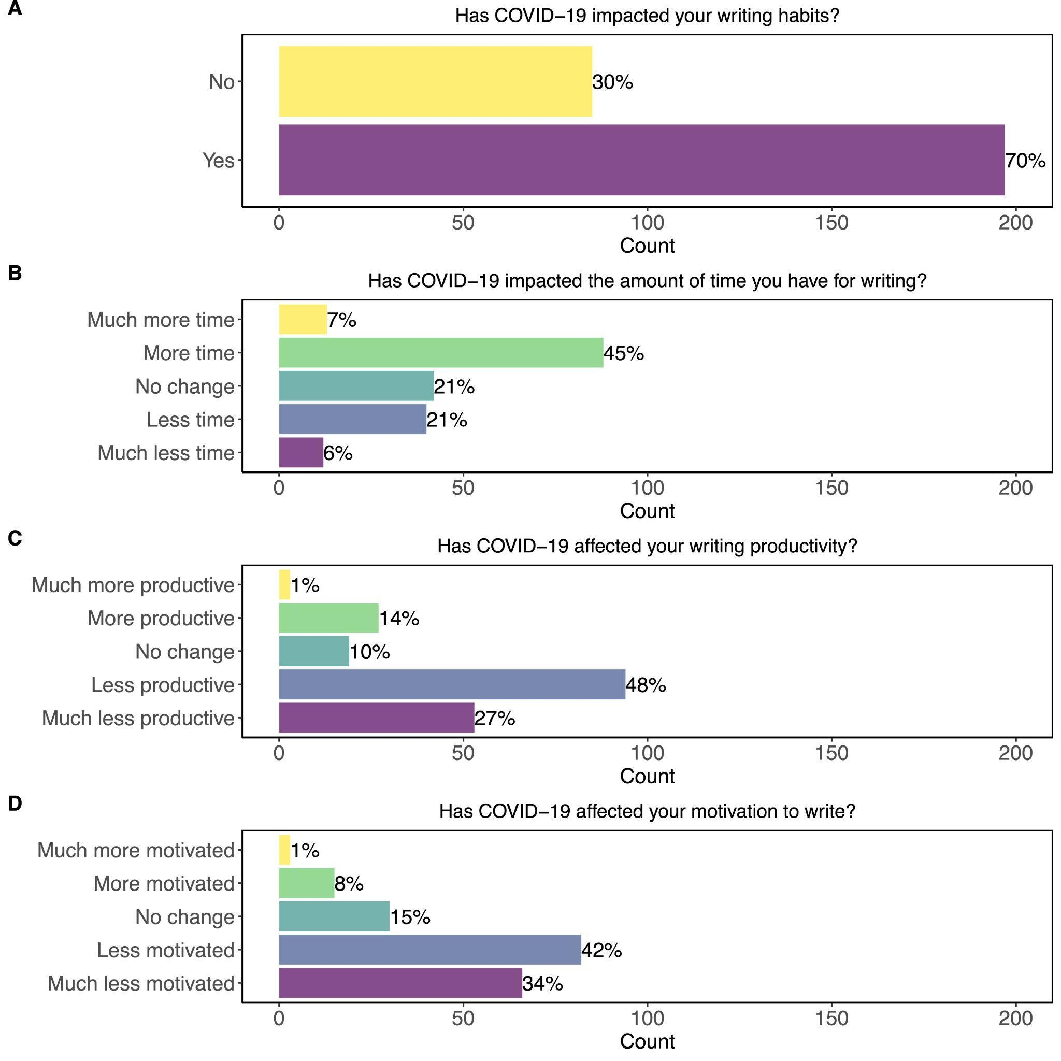

**Fig. 3**. The impact of the COVID-19 pandemic on trainee writing habits and feelings of productivity and motivation. A) The majority of respondents said that the pandemic has affected their overall writing habits. B) While many respondents reported having more or much more time for writing, C) most respondents reported that they felt less or much less productive during the pandemic. D) Similarly, the majority of respondents reported feeling less or much less motivated.

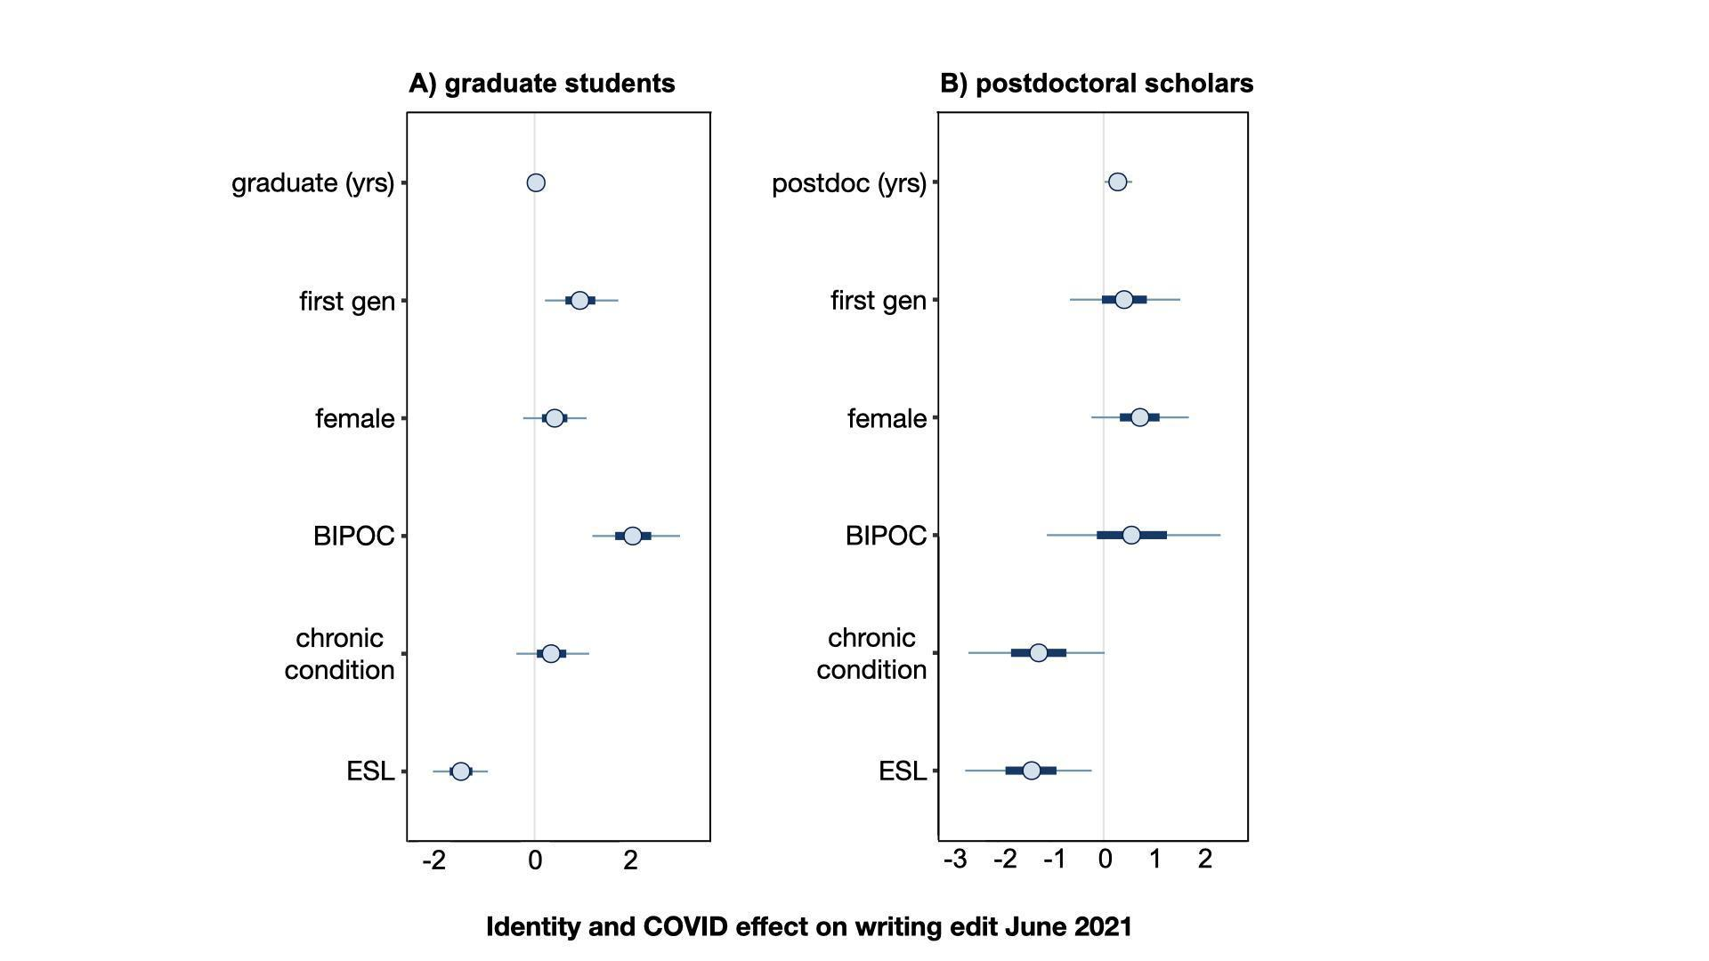

**Fig. 4.** Binomial multiple regression models suggest identity of graduate students and postdoctoral scholars influenced yes/no responses of A) graduate students (n = 229) and B) postdoctoral scholars (n = 79) to the question “*Has COVID-19 impacted your writing habits?*” All estimates are in logit scale for ease of comparison. More positive values indicate a higher probability of answering “yes.” Points are the parameter estimate medians, thick lines are 50% credible intervals (CRIs), and thin lines are 95% CRIs. Graduate and postdoc yrs indicate the number of years in training (as a continuous variable). First gen = first in family to graduate from college; female = female; BIPOC = Black, Indigenous, and/or a person of color; chronic condition = chronic health condition or disability; and ESL = English is the second language of respondents coded categorically (yes/no).

**Table 1.** In the optional open question “*Is there anything else you would like to add about your writing experiences?*” trainees with ESL were the only ones who responded about how their identity affected publishing. While the model indicated that having ESL was not detrimental to publication output, these stated experiences of trainees with ESL highlighted the challenges.

|  |  |  |
| --- | --- | --- |
| **Career stage** | **Gender identity** | **Comment** |
| graduate student | male | *“As a non-native speaker, the hardest part is to find the right words to properly communicate. But it is rewarding to see a final product, even if it's just a paragraph.”* |
| postdoc | male | *“English writing obligation is unfair”* |
| graduate student | female | *“[It is] especially hard being a non-native English speaker. Many mental roadblocks and perfectionism make it nearly impossible to be motivated to write. Also, I don't get positive feedback often enough, which makes me feel like I'm not writing well enough and not capable of science.”* |
| postdoc | male | *“Many times I don't know how to express what's in my mind in English. [I spend] a lot of time to find appropriate words for what I want to say.”* |
| graduate student | female | *“The most difficult part for me has been training my brain to think in English. My first language is Spanish and I learned English …[at] 23 years old, so always I need a native speaker to check my docs. The [lack of] language diversity in science obligates people to think, write, and speak in English, which makes it difficult ...”* |
| postdoc | none given | *“A lot of people have issues due to [having ESL] and it should be taken more into account in Academia.”* |
| graduate student | female | “*I have found writing challenging, especially because English is my second language…”* |

**Box 1. Terminology**

We have strived to be as inclusive as possible throughout the process of creating and distributing our survey, as well as through our choice of language. When discussing **identity** as a whole, we used the American Psychological Association [(VandenBos 2007)](https://www.zotero.org/google-docs/?MFxSP3) definition as “an individual’s sense of self defined by (a) a set of physical, psychological, and interpersonal characteristics that is not wholly shared with any other person and (b) a range of affiliations (e.g., ethnicity) and social roles.” Here we describe the identity terminology that we chose to use in our survey and writing. To remain consistent, we use these terms throughout our writing.

We asked survey respondents to self-identify their gender as “**female**,” “**male**,” “**non-binary/third gender**,” or they could select “**prefer to self-identify**.” Thus, when referring to female and male genders we are not implying the biological sex of individuals, but rather employing the terms as adjectives of their gender identity.

We use **Black, Indigenous, and people of color (BIPOC)** to refer to groups that have faced and are facing racism. Where possible, we try to center all these groups rather than using the term non-white, which still centers white people. We recognize that BIPOC individuals come from diverse and unique backgrounds, and therefore do not all have the same experience. In the survey, individuals specified whether they identified as BIPOC or not.

The term individuals with a **chronic condition** describes individuals with a chronic health condition or disability. We understand that many people within the disability community prefer person-first language (e.g., person with a disability), while others prefer identity-first language (e.g., disabled person). We use the term individuals with a chronic condition to be inclusive of all types of disability and chronic health conditions.

Trainees with **English as a second language (ESL)** were those who did not have English as their first language. We use the term ESL to encompass trainees who speak English as a foreign language (EFL) and English as an additional language (EAL). We did not differentiate international trainees (i.e., those studying or working in countries that are not their native country) and in-country trainees with ESL, but we recognize that many respondents with ESL may also be international trainees.

**Historically excluded groups (HEGs)** refers to any group of people who have been excluded from full rights and privileges based on historical systems of oppression. This can include (but is not limited to) female individuals, transgender individuals, non-binary or third gender individuals, BIPOC individuals, and individuals with chronic health conditions. We chose not to use the term ‘underrepresented minority’ as the term ‘historically excluded’ better encompasses the power dynamics and systems of oppression that governed which groups were excluded. The term HEG is also commonly used in publications, such as in Dodson et al. 2009, Ramos et al. 2021, and Berhe et al. 2022.

**References cited**

[Abbott A. 2021. COVID’s mental-health toll: how scientists are tracking a surge in depression. Nature 590: 194–195.](https://www.zotero.org/google-docs/?X5wAQ5)

[Ahmed MA, Behbahani AH, Brückner A, Charpentier CJ, Morais LH, Mallory S, Pool A-H. 2020. The precarious position of postdocs during COVID-19. Science 368: 957.2-958.](https://www.zotero.org/google-docs/?X5wAQ5)

[Allison D, Cooley L, Lewkowicz J, Nunan D. 1998. Dissertation writing in action: The development of a dissertation writing support program for ESL graduate research students. English for Specific Purposes 17: 199–217.](https://www.zotero.org/google-docs/?X5wAQ5)

[Andersen JP, Nielsen MW, Simone NL, Lewiss RE, Jagsi R. 2020. COVID-19 medical papers have fewer women first authors than expected. eLife 9: e58807.](https://www.zotero.org/google-docs/?X5wAQ5)

Berhe AA, Barnes RT, Hastings MG, Mattheis A, Schneider B, Williams BM, Marín-Spiotta E. 2022. Scientists from historically excluded groups face a hostile obstacle course. Nature Geoscience 15: 2-4.

[Beisner BE, Haydon DT, Cuddington K. 2003. Alternative stable states in ecology. Frontiers in Ecology and the Environment 1: 376–382.](https://www.zotero.org/google-docs/?X5wAQ5)

[Bell ML, Fong KC. 2021. Gender Differences in First and Corresponding Authorship in Public Health Research Submissions During the COVID-19 Pandemic. American Journal of Public Health 111: 159–163.](https://www.zotero.org/google-docs/?X5wAQ5)

[Brischoux F, Angelier F. 2015. Academia’s never-ending selection for productivity. Scientometrics 103: 333–336.](https://www.zotero.org/google-docs/?X5wAQ5)

[Cardel MI, Dean N, Montoya-Williams D. 2020. Preventing a Secondary Epidemic of Lost Early Career Scientists. Effects of COVID-19 Pandemic on Women with Children. Annals of the American Thoracic Society 17: 1366–1370.](https://www.zotero.org/google-docs/?X5wAQ5)

[Charleston LJ, Adserias RP, Lang NM, Jackson, JFL. 2014. Intersectionality and STEM: The Role of Race and Gender in the Academic Pursuits of African American Women in STEM. Journal of Progressive Policy and Practice 2: 21.](https://www.zotero.org/google-docs/?X5wAQ5)

[Clauset A, Arbesman S, Larremore DB. 2015. Systematic inequality and hierarchy in faculty hiring networks. Science Advances 1: e1400005.](https://www.zotero.org/google-docs/?X5wAQ5)

[Cronin MR, Alonzo SH, Adamczak SK, Baker DN, Beltran RS, Borker AL, Favilla AB, Gatins R, Goetz LC, Hack N. 2021. Anti-racist interventions to transform ecology, evolution and conservation biology departments. Nature Ecology & Evolution 1–11.](https://www.zotero.org/google-docs/?X5wAQ5)

[Demery A-JC, Pipkin MA. 2021. Safe fieldwork strategies for at-risk individuals, their supervisors and institutions. Nature Ecology & Evolution 5: 5–9.](https://www.zotero.org/google-docs/?X5wAQ5)

Dodson, JE, Montgomery, BL, Brown LJ. 2009. “Take the Fifth”: Mentoring Students Whose Cultural Communities Were Not Historically Structured Into U.S. Higher Education. Innovative Higher Education 34: 185-199.

[Evans TM, Bira L, Gastelum JB, Weiss LT, Vanderford NL. 2018. Evidence for a mental health crisis in graduate education. Nature Biotechnology 36: 282–284.](https://www.zotero.org/google-docs/?X5wAQ5)

[Fox J. 2020. A Data‐Based Guide to the North American Ecology Faculty Job Market. The Bulletin of the Ecological Society of America 101.](https://www.zotero.org/google-docs/?X5wAQ5)

[Gabry J, Mahr T. 2020. bayesplot: Plotting for Bayesian Models.](https://www.zotero.org/google-docs/?X5wAQ5)

[Gardner SA, Salto LM, Riggs ML, Casiano CA, De Leon M. 2018. Supporting the Writing Productivity of Biomedical Graduate Students: An Integrated, Structured Writing Intervention. CBE—Life Sciences Education 17: ar45.](https://www.zotero.org/google-docs/?X5wAQ5)

[Goodrich B, Gabry J, Brilleman S. 2020. rstanarm: Bayesian applied regression modeling via Stan.](https://www.zotero.org/google-docs/?X5wAQ5)

[Grady RK, La Touche R, Oslawski-Lopez J, Powers A, Simacek K. 2014. Betwixt and Between: The Social Position and Stress Experiences of Graduate Students. Teaching Sociology 42: 5–16.](https://www.zotero.org/google-docs/?X5wAQ5)

[Hansen WD, Scholl JP, Sorensen AE, Fisher KE, Klassen JA, Calle L, Kandlikar GS, Kortessis N, Kucera DC, Marias DE, Narango DL, O’Keeffe K, Recart W, Ridolfi E, Shea ME. 2018. How do we ensure the future of our discipline is vibrant? Student reflections on careers and culture of ecology. Ecosphere 9: e02099.](https://www.zotero.org/google-docs/?X5wAQ5)

[Herman E, Nicholas D, Watkinson A, Rodríguez-Bravo B, Abrizah A, Boukacem-Zeghmouri C, Jamali HR, Sims D, Allard S, Tenopir C, Xu J, Świgoń M, Serbina G, Cannon LP. 2021. The impact of the pandemic on early career researchers: what we already know from the internationally published literature. El profesional de la información e300208.](https://www.zotero.org/google-docs/?X5wAQ5)

[Jimenez MF, Laverty TM, Bombaci SP, Wilkins K, Bennett DE, Pejchar L. 2019. Underrepresented faculty play a disproportionate role in advancing diversity and inclusion. Nature Ecology & Evolution 3: 1030–1033.](https://www.zotero.org/google-docs/?X5wAQ5)

[Kelsky K. 2020. The professor is in: Stranded on the academic job market this year. The Chronicle of Higher Education.](https://www.zotero.org/google-docs/?X5wAQ5)

[Ko LT, Kachchaf RR, Ong M, Hodari AK. 2013. Narratives of the double bind: Intersectionality in life stories of women of color in physics, astrophysics and astronomy. Paper presented at 2012 PHYSICS EDUCATION RESEARCH CONFERENCE. 2013, Philadelphia, PA, USA.](https://www.zotero.org/google-docs/?X5wAQ5)

[Lax J. 2002. Academic writing for international graduate students. Paper presented at 32nd Annual Frontiers in Education. November 2002.](https://www.zotero.org/google-docs/?X5wAQ5)

[Levine RL, Rathmell WK. 2020. COVID-19 impact on early career investigators: a call for action. Nature Reviews Cancer 20: 357–358.](https://www.zotero.org/google-docs/?X5wAQ5)

[Maas B, Grogan KE, Chirango Y, Harris N, Liévano-Latorre LF, McGuire KL, Moore AC, Ocampo-Ariza C, Palta MM, Perfecto I, Primack RB, Rowell K, Sales L, Santos-Silva R, Silva RA, Sterling EJ, Vieira RRS, Wyborn C, Toomey A. 2020. Academic leaders must support inclusive scientific communities during COVID-19. Nature Ecology & Evolution 4: 997–998.](https://www.zotero.org/google-docs/?X5wAQ5)

[Martinez ED, Botos J, Dohoney KM, Geiman TM, Kolla SS, Olivera A, Qiu Y, Rayasam GV, Stavreva DA, Cohen‐Fix O. 2007. Falling off the academic bandwagon: Women are more likely to quit at the postdoc to principal investigator transition. EMBO reports 8: 977–981.](https://www.zotero.org/google-docs/?X5wAQ5)

[Mendoza-Denton R, Patt C, Fisher A, Eppig A, Young I, Smith A, Richards MA. 2017. Differences in STEM doctoral publication by ethnicity, gender and academic field at a large public research university. PLOS ONE 12: e0174296.](https://www.zotero.org/google-docs/?X5wAQ5)

Montgomery BL. 2021. Make equity essential to expedite change in academia. Nature Microbiology 6: 7-8.

[Myers KR, Tham WY, Yin Y, Cohodes N, Thursby JG, Thursby MC, Schiffer P, Walsh JT, Lakhani KR, Wang D. 2020. Unequal effects of the COVID-19 pandemic on scientists. Nature Human Behaviour 4: 880–883.](https://www.zotero.org/google-docs/?X5wAQ5)

[National Science Foundation, National Center for Science and Engineering Statistics. 2019. Women, minorities, and persons with disabilities in science and engineering: 2019. Report no. NSF 19-304.](https://www.zotero.org/google-docs/?X5wAQ5)

[Nocco MA, McGill BM, MacKenzie CM, Tonietto RK, Dudney J, Bletz MC, Young T, Kuebbing SE. 2021. Mentorship, equity, and research productivity: lessons from a pandemic. Biological Conservation 255: 108966.](https://www.zotero.org/google-docs/?X5wAQ5)

[Nuyen S. 2021. Anti-Asian Attacks Rise During Pandemic. Read NPR’s Stories On The Surge In Violence. NPR.org. (30 June 2021; https://www.npr.org/2021/03/17/978055571/anti-asian-attacks-rise-during-pandemic-read-nprs-stories-on-the-surge-in-violen).](https://www.zotero.org/google-docs/?X5wAQ5)

[Ojha A. 2020. Is Pandemic a Class-Ridden? An Appraisal from New York City. Journal of Ethnic and Cultural Studies 7: 129.](https://www.zotero.org/google-docs/?X5wAQ5)

[Park DS. 2020. The Invisible University Is COVID-19 Positive. Trends in Genetics 36: 543–544.](https://www.zotero.org/google-docs/?X5wAQ5)

[Pinho-Gomes A-C, Peters S, Thompson K, Hockham C, Ripullone K, Woodward M, Carcel C. 2020. Where are the women? Gender inequalities in COVID-19 research authorship. BMJ Global Health 5: e002922.](https://www.zotero.org/google-docs/?X5wAQ5)

[Powell K. 2012. Publishing: Foreign tongues. Nature 487: 129–131.](https://www.zotero.org/google-docs/?X5wAQ5)

[R Core Team. 2020. R: A Language and Environment for Statistical Computing. R Foundation for Statistical Computing.](https://www.zotero.org/google-docs/?X5wAQ5)

Ramos JM, Elliot JS, Fattore C, Breuning M. 2021. Anxiety and the Onset of COVID-19: Examining Concerns of Historically Excluded Scholars. International Studies Perspectives: ekab017.

[Roksa J, Feldon DF, Maher M. 2018. First-Generation Students in Pursuit of the PhD: Comparing Socialization Experiences and Outcomes to Continuing-Generation Peers. The Journal of Higher Education 89: 728–752.](https://www.zotero.org/google-docs/?X5wAQ5)

[Rybarczyk BJ, Lerea L, Whittington D, Dykstra L. 2016. Analysis of Postdoctoral Training Outcomes That Broaden Participation in Science Careers. CBE—Life Sciences Education 15: ar33.](https://www.zotero.org/google-docs/?X5wAQ5)

[Sanchis‐Gomar F. 2014. How does the journal impact factor affect the CV of Ph.D. students? EMBO reports 15: 207–207.](https://www.zotero.org/google-docs/?X5wAQ5)

[Schell CJ, Guy C, Shelton DS, Campbell-Staton SC, Sealey BA, Lee DN, Harris NC. 2020. Recreating Wakanda by promoting Black excellence in ecology and evolution. Nature Ecology & Evolution 4: 1285–1287.](https://www.zotero.org/google-docs/?X5wAQ5)

[Stan Development Team. 2020. RStan: the R interface to Stan.](https://www.zotero.org/google-docs/?X5wAQ5)

[Suart C, Suart TN, Graham K, Truant R. 2020. When the Labs Closed: Graduate Students’ and Postdoctoral Fellows’ Experiences of Disrupted Research During the COVID-19 Pandemic. In Review.](https://www.zotero.org/google-docs/?X5wAQ5)

[Tseng M, El-Sabaawi RW, Kantar MB, Pantel JH, Srivastava DS, Ware JL. 2020. Strategies and support for Black, Indigenous, and people of colour in ecology and evolutionary biology. Nature Ecology & Evolution 4: 1288–1290.](https://www.zotero.org/google-docs/?X5wAQ5)

[Valian V. 2004. Beyond Gender Schemas: Improving the Advancement of Women in Academia. NWSA Journal 16: 207–220.](https://www.zotero.org/google-docs/?X5wAQ5)

[VandenBos GR. 2007. APA dictionary of psychology. American Psychological Association.](https://www.zotero.org/google-docs/?X5wAQ5)

[Walker B, Holling CS, Carpenter SR, Kinzig A. 2004. Resilience, Adaptability and Transformability in Social–ecological Systems. Ecology and Society 9.](https://www.zotero.org/google-docs/?X5wAQ5)

[Woolston C. 2020a. Signs of depression and anxiety soar among US graduate students during pandemic. Nature 585: 147–148.](https://www.zotero.org/google-docs/?X5wAQ5)

[Woolston C. 2020b. Pandemic darkens postdocs’ work and career hopes. Nature 585: 309–312.](https://www.zotero.org/google-docs/?X5wAQ5)

**ETHICS DECLARATIONS**

The authors declare no conflicts of interest.

**DATA STATEMENT**

We have another manuscript in prep from this work, and will publish the complete dataset on Dryad once it is published for anyone to use. If BioScience needs us to publish the data we used in this manuscript sooner, we will gladly do that.

**SHORT BIOGRAPHICAL NARRATIVE**

*Freya E. Rowland ([frowland@usgs.gov](mailto:frowland@usgs.gov)) was a Donnelley Postdoctoral Fellow with the Yale Institute for Biospheric Sciences, New Haven, CT, USA and is currently a Research Ecologist with the U.S. Geological Survey at the Columbia Environmental Research Center in Columbia, MO, USA. Kyra A. Prats has a PhD in plant ecophysiology from the Yale School of the Environment, New Haven, CT, USA. Yara A. Alshwairikh is a PhD candidate in evolutionary ecology at the Yale School of the Environment, New Haven, CT, USA. Mary K. Burak is a PhD candidate in carnivore ecology at the Yale School of the Environment, New Haven, CT, USA. Ana Clara Fanton has a PhD in plant physiology at the Yale School of the Environment, New Haven, CT, USA. Marlyse C. Duguid is a Senior Lecturer, Research Scientist, and Director of Research for Yale Forests in the Yale School of the Environment, New Haven, CT, USA.*